SeanProject 2

CMSC 335 6380

February 04, 2020

Professor Osama Morad

Sean Hamilton Student

UML

USER GUIDE

**SETUP**

This program is created in the Java language, running build 1.8.0_191, and therefore requires the Java JDK version 8.0 or greater installed. The program was developed in the Eclipse IDE for Java EE and the link for this specific IDE can be found [here](https://www.eclipse.org/downloads/packages/release/2019-12/r/eclipse-ide-enterprise-java-developers) . An IDE is not required to run and execute this code and the user guide will be showing a command line alternative to running the program.

1. Download and extract zip file into folder named *SeanHamiltonProjectTwo*.
2. Take the gif file(*sphere.gif)* and the four png files (*torus.png, cube.png, cone.png, cylinder.png*) and copy them over to your desktop as the program will be looking in the user’s desktop for the images.
3. Open a command line tool and compile all classes.
4. Run the program.

*All steps shown in screenshot’s below*

Step 1.

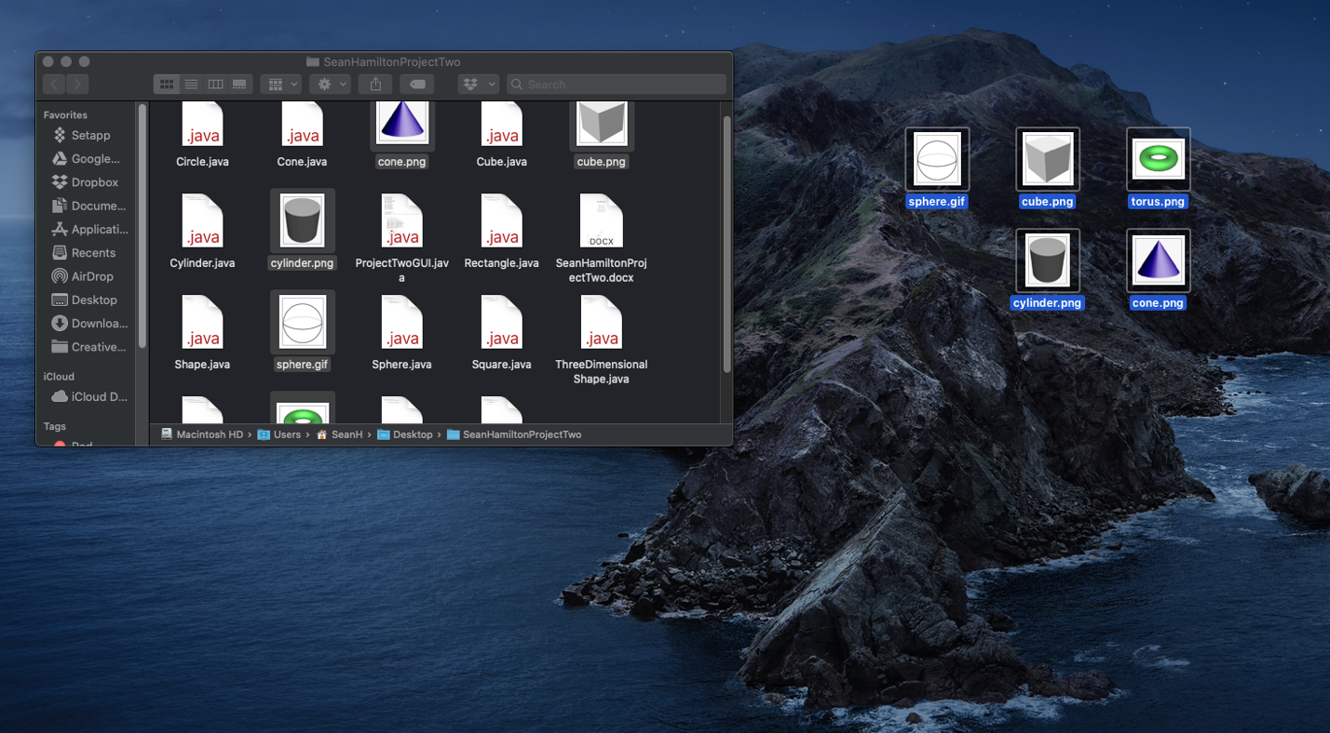

Step 2.

Steps 3 & 4.

**Test Plan**

|  |  |  |
| --- | --- | --- |
| **Aspect Testing** | **Actual Output** | **Pass?** |
| Entry for Circle.  Invalid Entry input for circle. | A screenshot of a computer  Description automatically generated  Circle Entry – pops up window to ask radius  A screenshot of a computer  Description automatically generated  Circle entry – shows drawing and area in new window  A screenshot of a computer  Description automatically generated  Error handling for radius | Yes |
| Entry for Rectangle  Error handling for Rectangle | A screenshot of a computer  Description automatically generated  Rectangle asks for length and width  A screenshot of a computer  Description automatically generated  Rectangle successful draws red rectangle and displays area.  A screenshot of a computer  Description automatically generated  Rectangle Error handling | Yes |
| Entry for Square  Error handling for Square | Square asks for length of side  A screenshot of a computer  Description automatically generatedA screenshot of a computer  Description automatically generated  Square successful draws red square and displays area.  A screenshot of a computer  Description automatically generated  Square Error handling | Yes |
| Entry for Triangle  Error handling for Triangle | A screenshot of a computer  Description automatically generated  Triangle asks for base and height  A screenshot of a computer  Description automatically generated  Triangle successful draws Triangle and displays area.  A screenshot of a computer  Description automatically generated  Triangle Error handling | Yes |
| Entry for Sphere  Error handling for Sphere | A screenshot of a computer  Description automatically generated  Sphere successful draws Sphere and displays volume.  Sphere asks for radius  A screenshot of a computer  Description automatically generated  A screenshot of a computer  Description automatically generated  Sphere Error handling | Yes |
|  |  | Yes |
| Entry for Cube  Error handling for Cube | A screenshot of a computer  Description automatically generated  Cube successful pulls up image of Cube and displays volume.  Cube asks for edge  A screenshot of a computer  Description automatically generated  A screenshot of a computer  Description automatically generated  Cube Error handling | Yes |
| Entry for Cone  Error handling for Cone | A screenshot of a computer  Description automatically generated  Cone successful pulls up image of Cone and displays volume.  Cone asks for Radius and height  A screenshot of a computer  Description automatically generated  A screenshot of a computer  Description automatically generated  Cone Error handling | Yes |
| Entry for Cylinder  Error handling for Cylinder | A screenshot of a computer  Description automatically generated  Cylinder asks for Radius and height  A screenshot of a computer  Description automatically generatedA screenshot of a cell phone  Description automatically generated  Cylinder Error handling  Cylinder successful pulls up image of Cylinder and displays volume. | Yes |
| Entry for Torus  Error handling for Torus | A screenshot of a computer  Description automatically generated  Torus successful pulls up image of Torus and displays volume.  Torus asks for Major and Minor radius  A screenshot of a computer  Description automatically generated  A screenshot of a computer  Description automatically generated  Torus Error handling | Yes |

**LESSONS LEARNED**

This project was a great refresher of the java swing library. The way JFrame works with JPanels and how the GUI is constructed by a class extending the JFrame was something I have not done in a few years in Java. Drawing the rectangles, circles, and squares by extending JPanel and overriding the paint method is also a very useful and informative tactic in OOP. I feel this project was a great learning experience and there are several improvements I could have made including making methods for the event handler actions instead of having repeated code in if statements. I could have also split up the ProjectTwoGUI class into a couple different classes to modularize the code properly. I had a lot of fun coding this program and am looking forward to what is coming next!